### Compiling and Running the Program in Visual Studio

**Open Visual Studio:**

* 1. Load your project containing main.cpp, Acc.cpp, Comp.cpp, and Part.cpp.

**Running the Program:**

* 1. Once the build is successful, you can run the program by going to Debug > Start Without Debugging or pressing Ctrl+F5.
  2. This will execute the compiled program.

### How the Program Works

The program is a C++ application that allows users to build a custom computer by selecting various components such as CPU, RAM, motherboard, storage, and accessories. Users interact with the program through a menu-driven interface that offers the following options:

**View Current Build:**

* 1. Displays all the selected components and their details, along with the total cost.

**Add Parts:**

* 1. Users can select from different categories (e.g., CPU, RAM, Storage) to add parts to their build. The program enforces limits, like allowing only one CPU or a certain number of RAM sticks.

**Remove Parts:**

* 1. Users can remove specific components from their build if they wish to change their selection.

**Clear Build:**

* 1. Clears the entire build, allowing the user to start over from scratch.

**Exit:**

* 1. Ends the program.

UML:

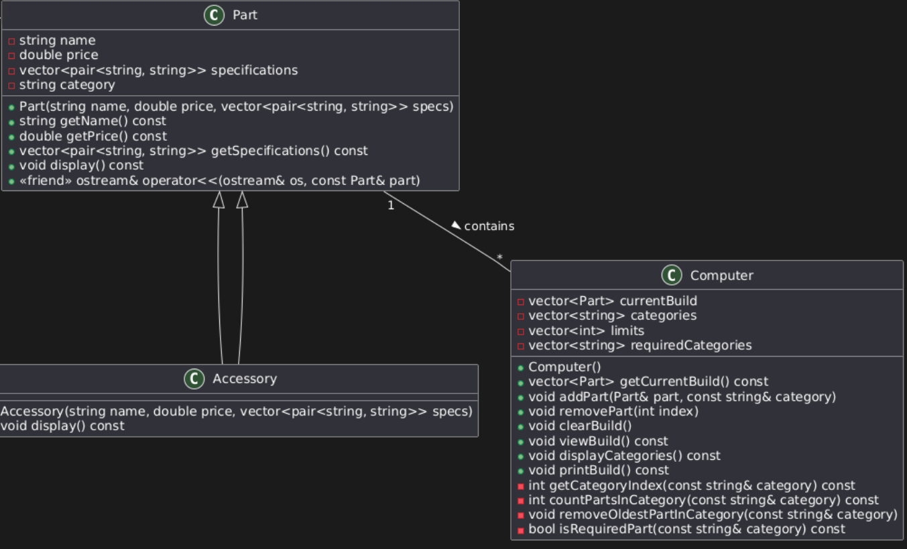

New Feature: Part Compatibility Check

Compatibility Checker

* What it does: Before allowing a user to add a part, the program checks if it is compatible with the other parts in the current build. For example, the motherboard should be compatible with the CPU socket type, RAM type, and GPU. If a user tries to add an incompatible part, the program would alert them and prevent the addition.
* How it helps: Ensures that users only create valid builds, preventing common mistakes like choosing incompatible parts.

2. Budget Constraint

* What it does: Allows users to set a budget for their build. As they add parts, the program will alert them if they exceed their budget, helping them stay within financial limits.
* How it helps: Aids users in managing their expenses and ensuring that they don't overspend while building their PC.

3. Pre-Built Recommendations

* What it does: Offers users several pre-built configurations based on different use cases, like gaming, video editing, or a budget build. Users can select one of these pre-configured builds and customize it further.
* How it helps: Provides a starting point for users who may not be as knowledgeable about building PCs, making it easier for them to get started.